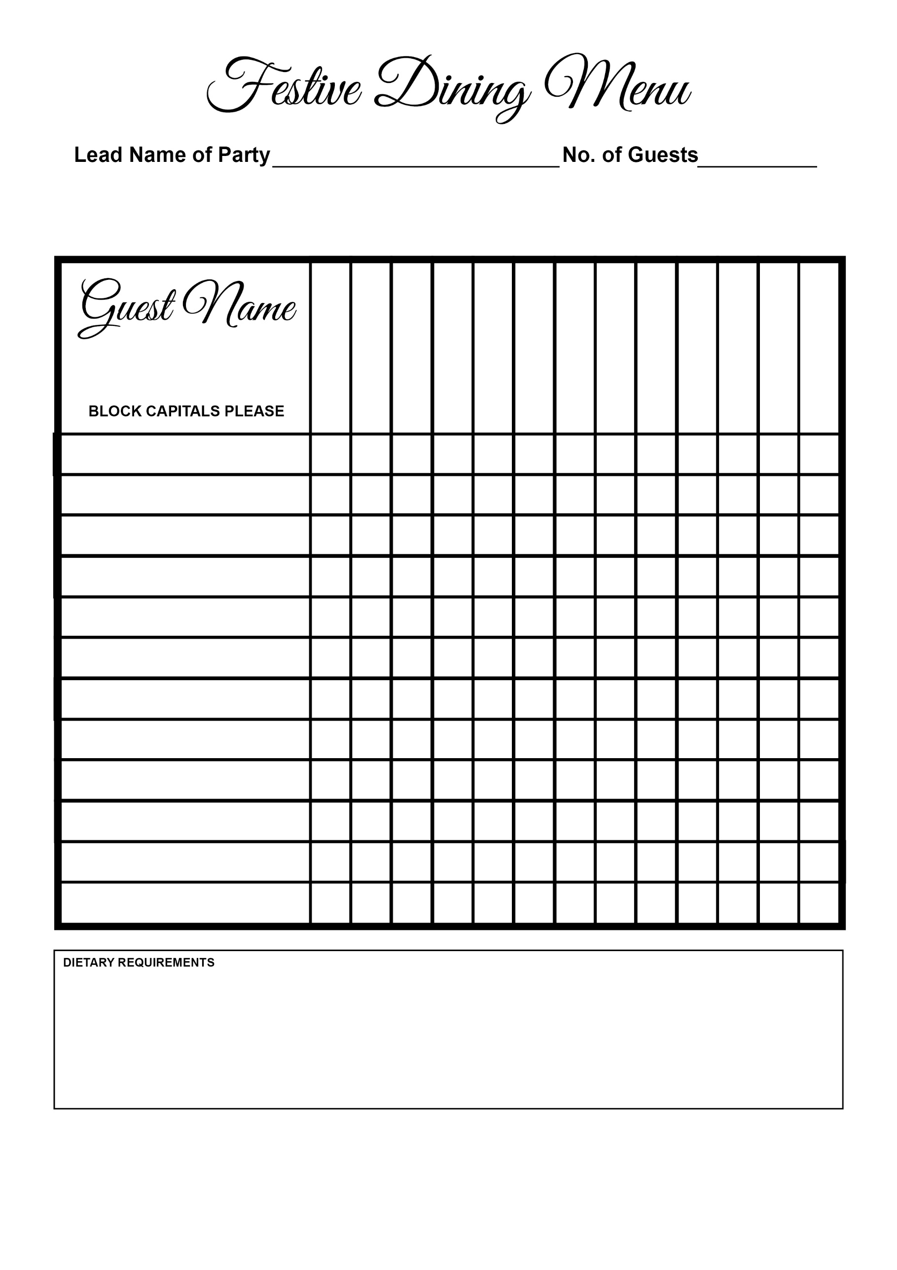

Chocolate & Pecan Torte

Cheesecake

Sticky Toffee Pudding

Parma Ham Salad

Profiteroles

Lentil Fritter

Salmon

Beef

Turkey

Prawn

Melon

Soup