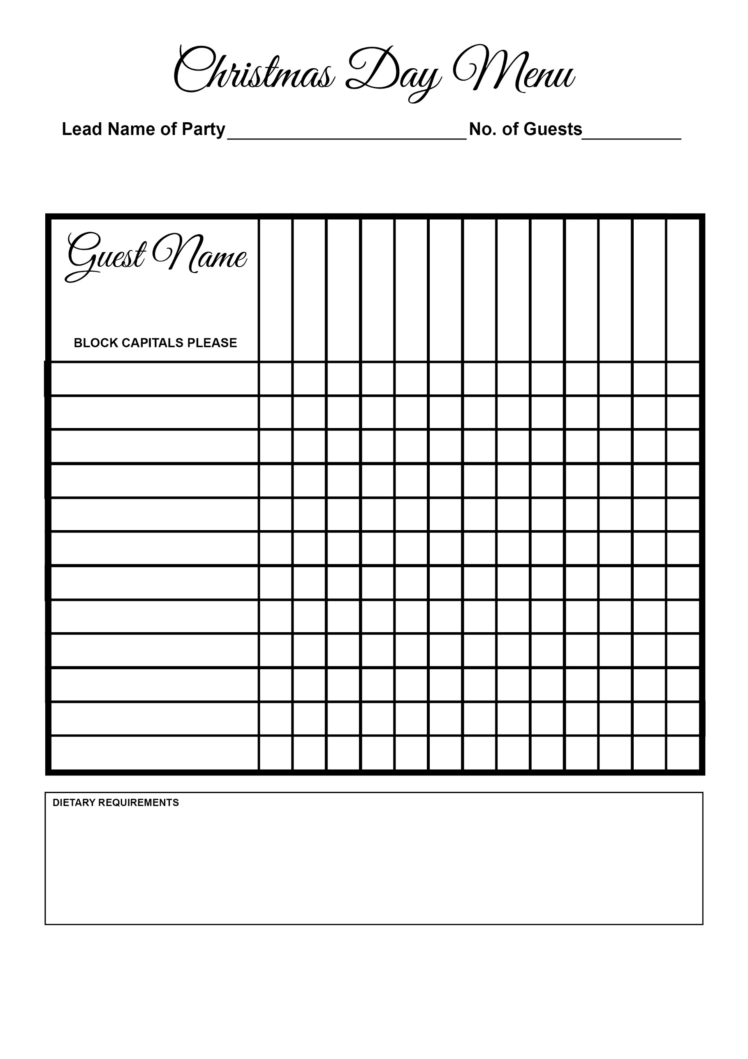

Selection Of Cheeses

Christmas Pudding

Desserts

Pear & Almond Tart

Cheesecake

Panna Cotta