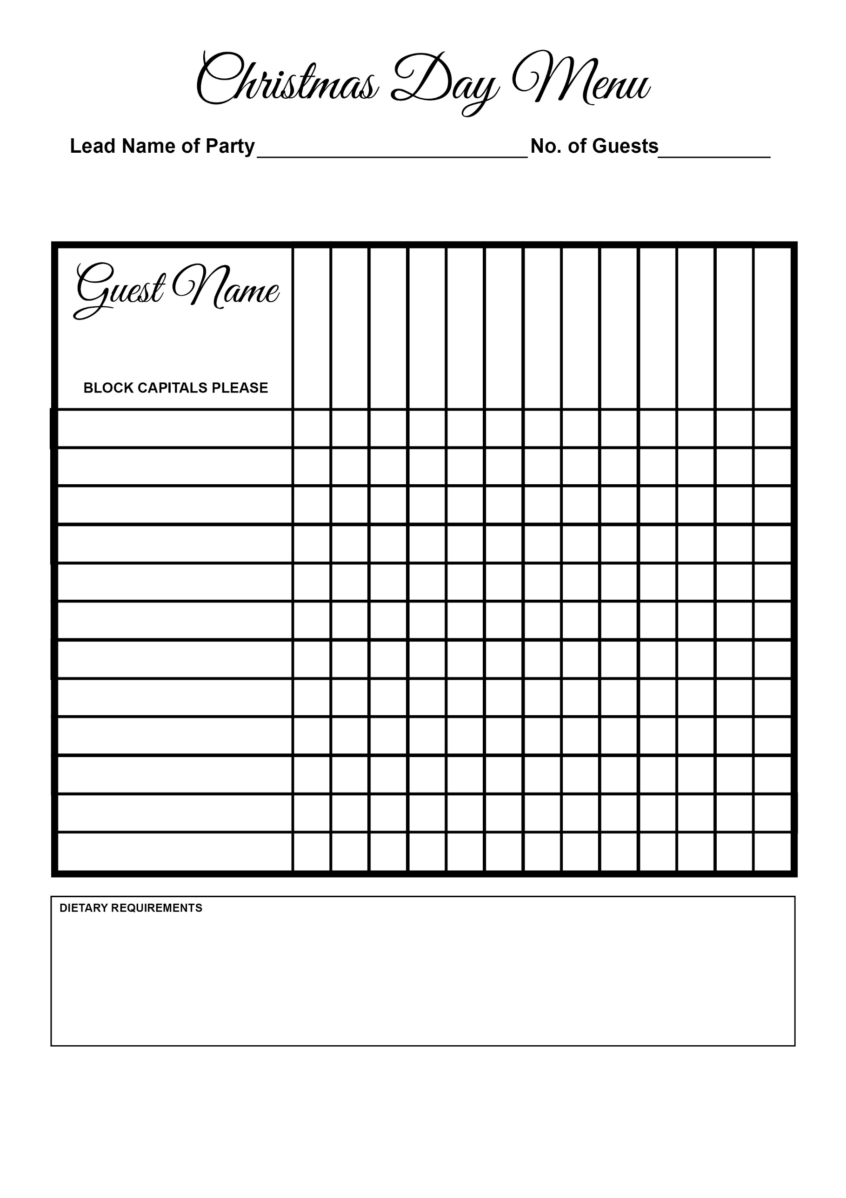

Starters & Mains

Sea Bass

Wellington

Duck

Beef

Turkey

Goat’s Cheese

Salmon

Game Terrine

Soup