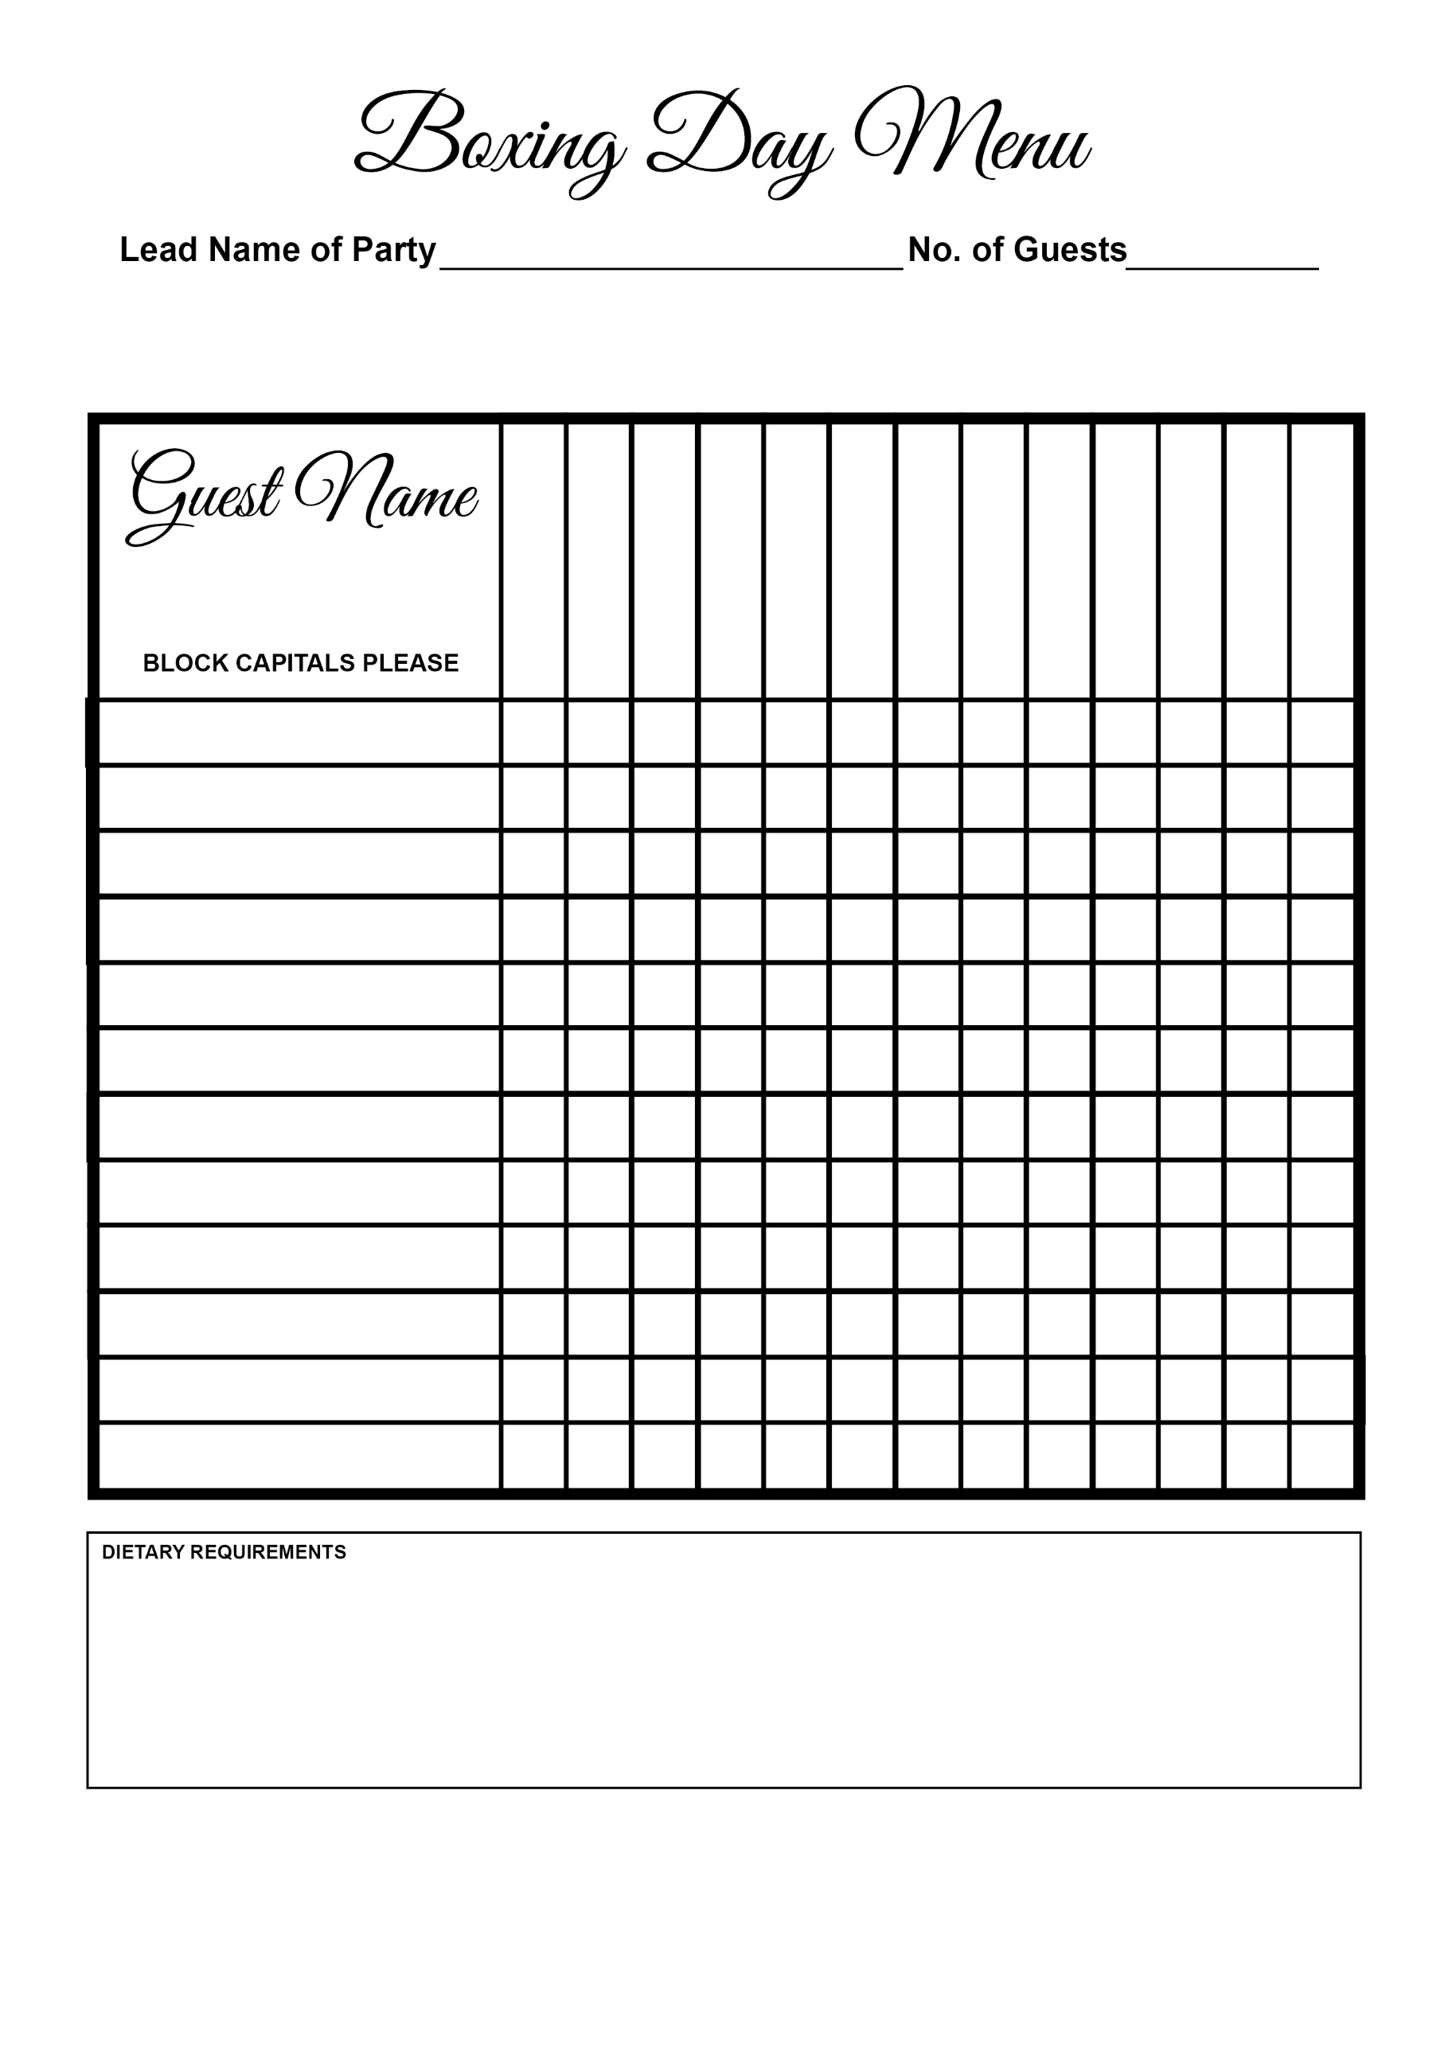



Gateau

Tarte Au Citron

Prawns

Aubergine Bake

Sherry Trifle

Apple Pie

Salmon

Duck

Beef

Gammon

Melon

Bubble & Squeak

Soup