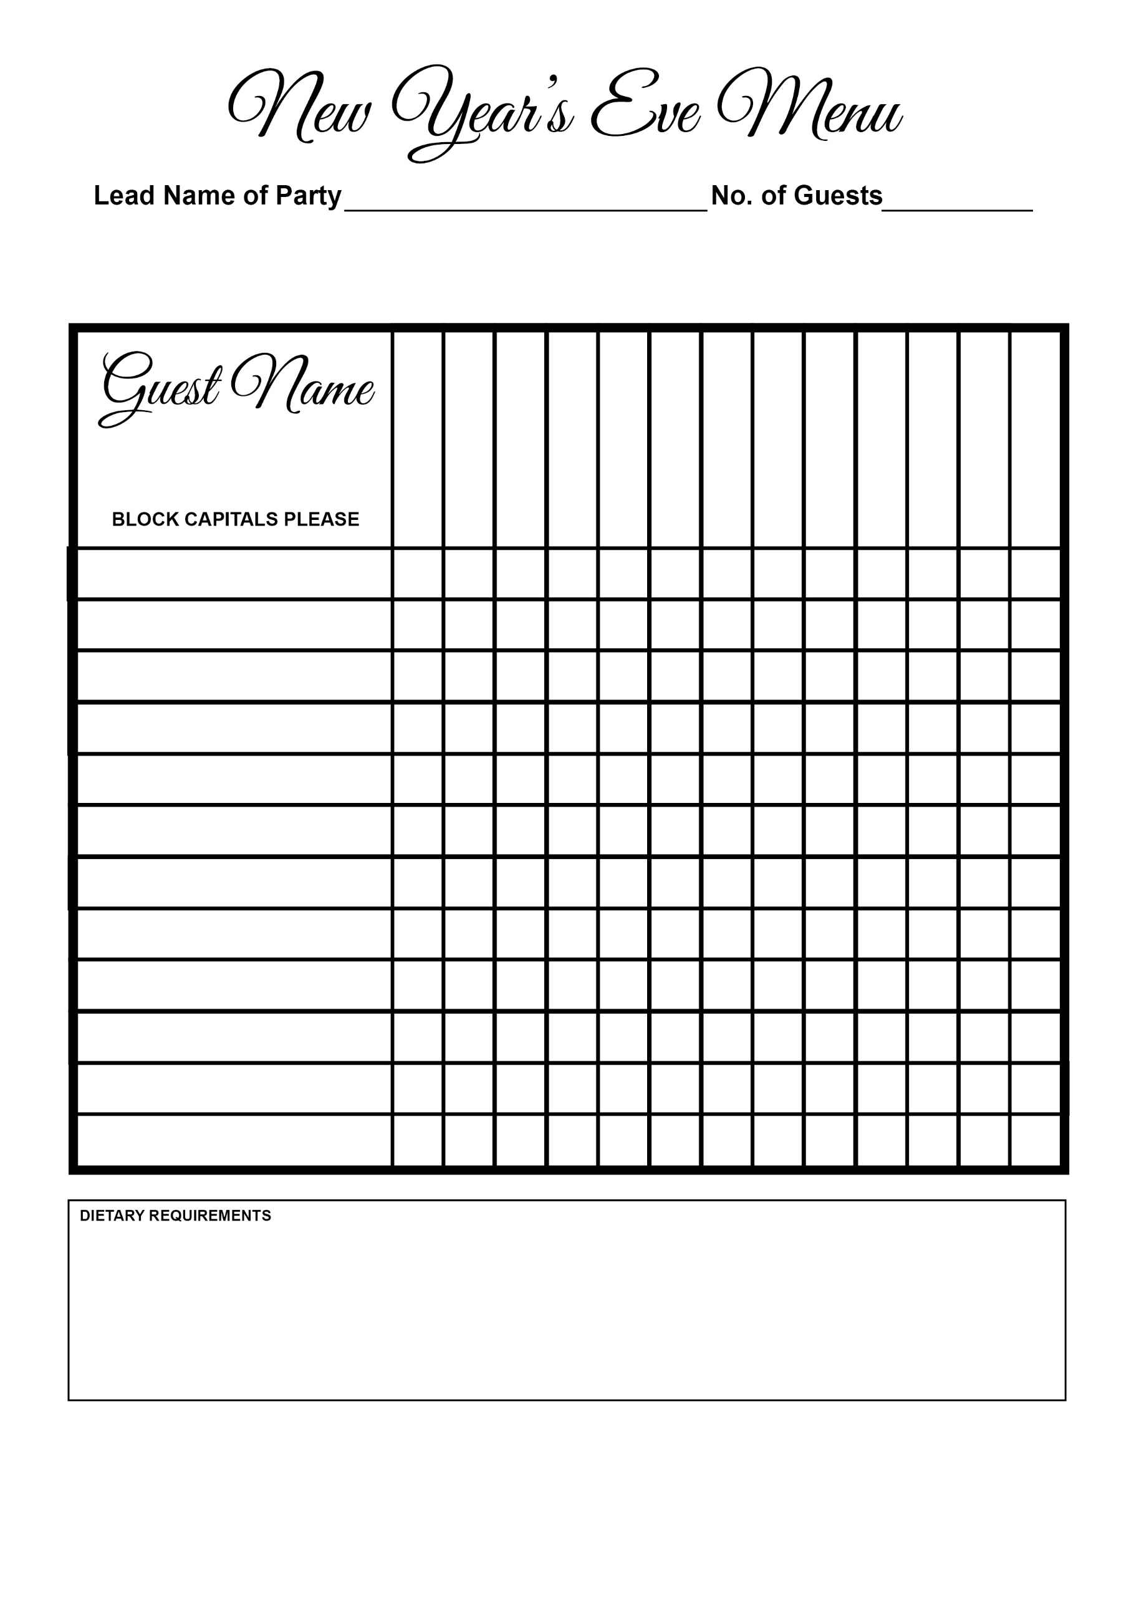

Soup

Salmon

Sorbet

Fillet Steak

Duck

Chicken Breast

Lemon Sole

Goat’s Cheese Tart

Selection Of Cheeses

Cheesecake

Salted Caramel Pot

Raspberry Posset

Orange & Banana Sponge